 

|  |
| --- |
|  |

|  |
| --- |
| *Software Engineering-1*  *Software Design Document*  *For*  *Web-Service to code project* |
| *Dr. Mohammad El Ramly*  *TA. Desoky Abdelqawy*  *Leader: Mariam Fouad Saeed*  *e-mail:*  *mariam-_-fouad@hotmail.com* |
| *Date:*  *November 8, 2014* |

Contents

Team 2

Document Purpose and Audience 2

System Models 2

System Decomposition 2

Class diagrams 3

Sequence diagrams 4

Class - Sequence Usage 4

User Interface Design 5

Screen 1 –start page (initial) 5

Screen 2 – select method names (initial) 5

Screen 3 – search for WSDL device 6

Ownership Report 6

# Team

|  |  |  |  |
| --- | --- | --- | --- |
| ID | Name | Email | Mobile |
| 20120493 | **Mariam Fouad Saeed** | **mariam-_-fouad@hotmail.com** | **01115658976** |
| 20120195 | **Salwa Ahmed Mahmoud** | **gaza_3ashekah@yahoo.com** | **01158379344** |
| 20120446 | **Huda Mohammad Abdel Raouf** | **huda.fci@gmail.com** | **01286204342** |
| 20120456 | **Yasmin Abdel Latif Mohammad** | **yasmeen.kloub@gmail.com** | **01275511358** |

# Document Purpose and Audience

* **The purpose of this document is to present a detailed description of the Web-Service to Code Project. It will show the detail of the project and how to implement the software.**
* **This document is intended for the project manager and team member to keep track of the project.**

# System Models

## System Decomposition

## Class diagrams

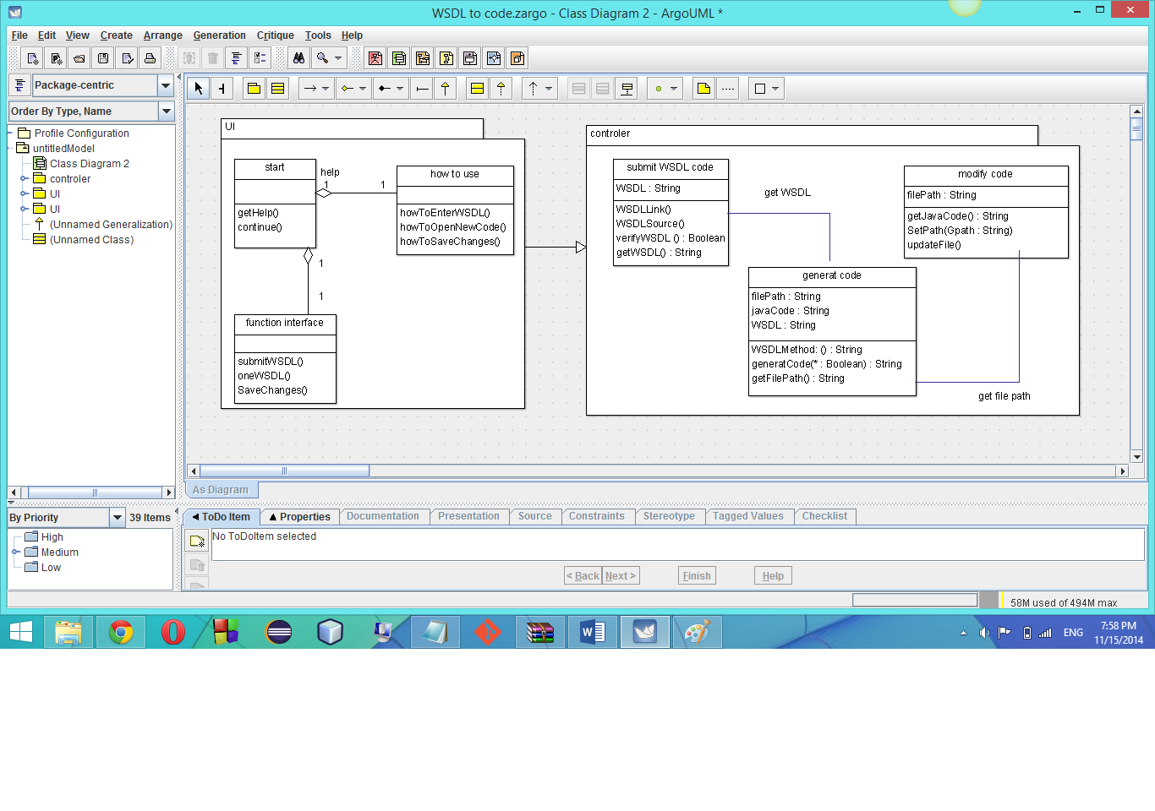

|  |  |  |  |
| --- | --- | --- | --- |
| **Class ID** | **Class Name** | **Subsystem ID** | **Description** |
| 001 | start | UI | Show the began UI of the software |
| 002 | HowToUse | UI | Show some help steps for the user |
| 003 | Function interface | UI | Show the general function to do |
| 004 | submitWSDLCode | controller | Check the validation of the WSDL |
| 005 | genrateWSDLCode | controller | Generate java code from the WSDL |
| 006 | modifyCode | controller | Modify the java code |

## Sequence diagrams

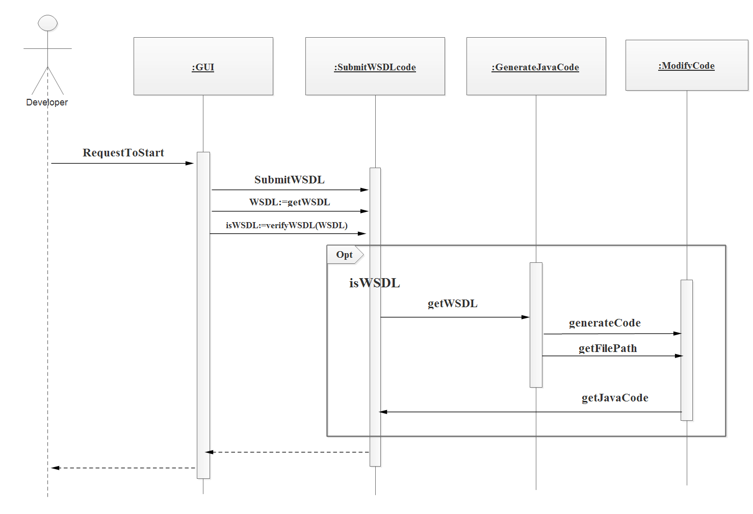

### Class - Sequence Usage

|  |  |  |
| --- | --- | --- |
| **Class Name** | **Sequence Diagrams** | **Overall used methods** |
| SubmitWSDLcode | 003,005,006 | SubmitWSDL,getWSDL,verifyWSDL |
| GenerateJavaCode | 004,006 | GetWSDL,generateCode,getFilePath |
| ModifyCode | 004,005 | getJavaCode |

## User Interface Design

### Screen 1 –start page (initial)

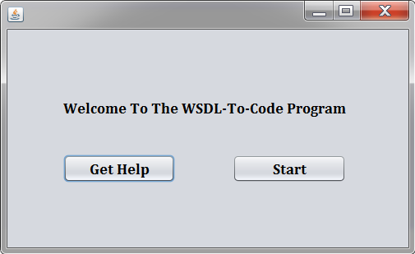

### Screen 2 – select method names (initial)

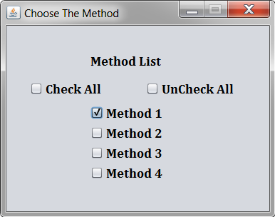

### Screen 3 – search for WSDL device

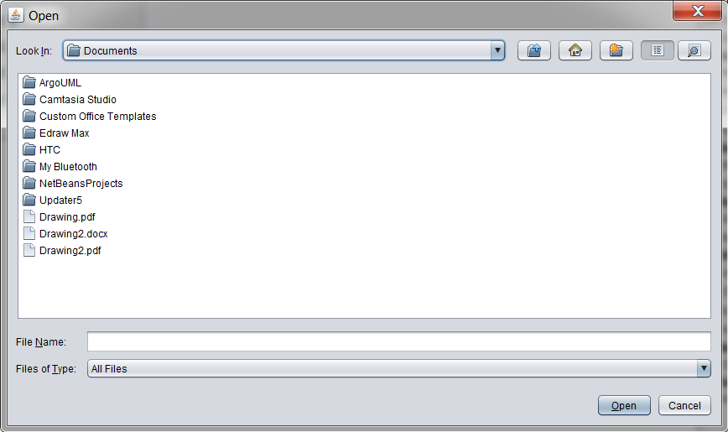

# Ownership Report

|  |  |
| --- | --- |
| Item | Owners |
| System Decomposition , Class diagrams | **Mariam Fouad** |
| Sequence diagrams , Class - Sequence Usage | **Yasmeen Abdel Latif** |
| System Models | **Salwa Ahmed** |
| Document Purpose and Audience , User Interface Design | **Huda Mohammed** |